How to use the ISE Interactive Curriculum Map:
Requirements:
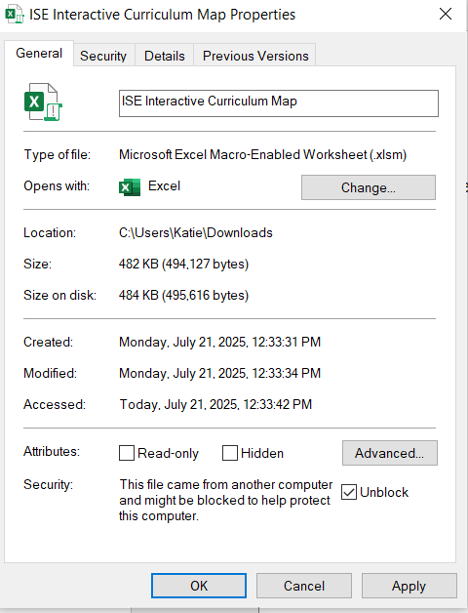
- GeneralYou must have Microsoft Excel installed to use this tool.
  - All UF Students, Faculty and Staff have access to
Microsoft Office: Link to Install
- This tool will NOT work in browser.
- This tool will NOT work on an iPad.
STEP 1: Download and Unblock the File:
- Download the Excel file to your computer.
- BEFORE opening in the file, go to the location where it was downloaded, right-click on the file name, and select:
  - -> Properties
  - -> Under the General tab: Check the Box to “Unblock” the file.
    - If there is no box, this step is already completed.
STEP 2: Save the tool to your computer.
- File type: Excel Macro-Enabled Workbook (*.xlsm)
- You only need to perform the unblock step once on your device.
STEP 3: Update ActiveX Settings in Excel
- Open Excel (you may need to open it without loading the file first).
- Go to: File -> Options -> Trust Center -> Trust Center Settings -> Active X Settings
- Select:
  - “Prompt me before enabling all controls with minimal conditions.”
- Close and re-open the file if necessary..
NEED HELP?
- If the file still does not open after completing these steps, please email Dr. Basinger-Ellis (katie.basinger@ufl.edu).
- If you have general ISE Advising questions, please contact the ISE Advising Office. Emails and appointment information can be found on our website: https://ise.ufl.edu/academics/advising/

