Spreadsheet Based Decision Support Systems
ESI 4356 Section 4677
Class Number 16894
Class Periods: T,R Periods 2-3, (8:30am – 10:25am)
Location: FLG 280
Academic Term: Spring 2026

Instructor:
Dr. Katie Basinger-Ellis
Email Address: katie.basinger@ufl.edu
Office Phone Number: (352)294-7730
Office Hours: TBD

Teaching Assistant/Peer Mentor/Supervised Teaching Student:
Please contact through email:
- Karissa Jackson
  - karissajackson@ufl.edu
  - Office Hours: TBD
- Emma Muscato
  - emma.muscato@ufl.edu
  - Office Hours: TBD
- Sabrina Bardi
  - sabrina.bardi@ufl.edu
  - Office Hours: TBD

Course Description
Applications of decision support systems in industrial and systems engineering; Developing and implementing decision support systems arising in industrial and systems engineering using popular database management and spreadsheet software; Microsoft Excel; Visual Basic for Excel. (4 credits).

Course Pre-Requisites / Co-Requisites
COP 2271/2273 – pre-requisite with minimum grade of C.
ESI 3312 – co-requisite (must have taken OR 1 with a minimum grade of C or be enrolled in the course in the same semester)

Course Objectives
To understand the usefulness of decision support systems arising in the practice of industrial and systems engineering; to become expert users of spreadsheets and to learn how to take advantage of a large array of tools available in spreadsheet programs; to learn how to accomplish tasks programmatically in a spreadsheet and how to design user friendly graphical user interfaces; to understand the issues that arise in the conceptual development and implementation of effective and user friendly decision support systems; to design, develop, and implement integrated decision support systems for industrial and systems engineering applications.

Materials and Supply Fees
Students will need their own laptop (preferably PC) with access to Microsoft Excel. See Required Textbooks and Software below.

Relation to Program Outcomes (ABET):
This is a course with significant design content. Throughout the semester, students will complete a team project expected to meet specific design criteria. This course supports the ISE undergraduate program educational objectives of producing graduates who
- “will be successful professionals in industrial and systems engineering or other disciplines”,
- “can acquire advanced knowledge through continuing education or advanced degree programs”
- “can become active leaders in their profession and/or community”

Outcome | Coverage*
- An ability to identify, formulate, and solve complex engineering problems by applying principles of engineering, science, and mathematics | High
- An ability to apply engineering design to produce solutions that meet specified needs with consideration of public health, safety, and welfare, as well as global, cultural, social, environmental, and economic factors | High
- An ability to communicate effectively with a range of audiences | High
- An ability to recognize ethical and professional responsibilities in engineering situations and make informed judgments, which must consider the impact of engineering solutions in global, economic, environmental, and societal contexts | Low
- An ability to function effectively on a team whose members together provide leadership, create a collaborative and inclusive environment, establish goals, plan tasks, and meet objectives | High
- An ability to develop and conduct appropriate experimentation, analyze and interpret data, and use engineering judgment to draw conclusions | Medium
- An ability to acquire and apply new knowledge as needed, using appropriate learning strategies | Low
*Coverage is given as high, medium, or low. An empty box indicates that this outcome is not covered or assessed in the course.

Required Textbooks and Software
No textbook is required. Lectures will be provided to students through videos posted on Canvas and in-class presentations. Other course materials, including instructions, slides, and exercises, can also be downloaded from the course website on Canvas.

Required Computer
UF student computing requirement: https://policy.ufl.edu/policy/student-computing-requirements/
Recommended Computer Specifications: https://it.ufl.edu/get-help/student-computer-recommendations/
HWCOE Computer Requirements: https://www.eng.ufl.edu/students/advising/fall-semester-checklist/computer-requirements/
NOTE: The above statements allow for a Windows or MAC device. For this course a Windows is preferred.

The development software required for this course is Microsoft Excel.
If you have a MAC you will need to be able to run Windows Parallels on your device, or plan to use a Windows device for programming. Although Excel works on a MAC there are limitations, and some functions are not accessible. If you choose to use a MAC as your main device for this course, support is limited due to instructor and TA usage of PC’s. There are online message boards that you can use for support.

iClicker: This is a free app. See the link on Canvas for more information about getting signed up and added to the course.

Link to join iClicker Class: https://join.iclicker.com/YWMI

Recommended Materials
Developing Spreadsheet-Based Decision Support Systems – Using Excel and VBA for Excel Authors: Michelle Seref, Ravindra Ahuja, and Wayne Winston ISBN: 0975914650

Course Schedule
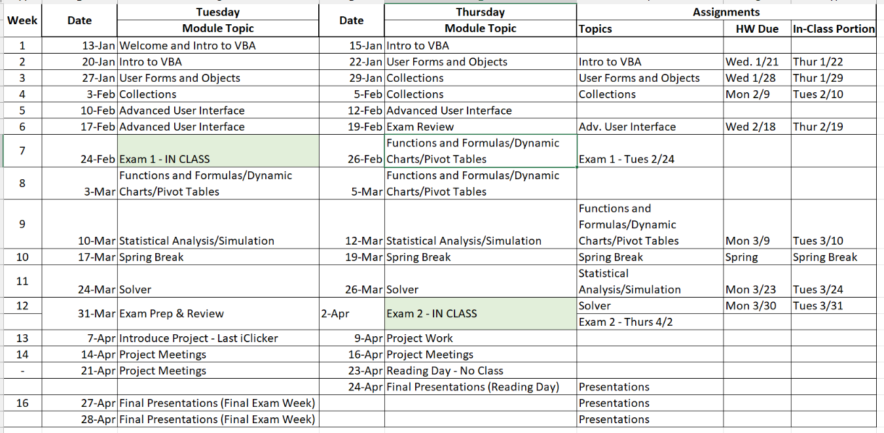

Important Dates
- 2/24/2026 - Exam 1 – In Class
- 4/2/2026 – Exam 2 – In Class
- 4/24/2026 (Reading Day)– Final Project Presentation Day
- 4/27/2026 & 4/28/2026 (Final Exam Week) – Final Presentation Days

Attendance Policy, Class Expectations, and Make-Up Policy
- This class is a flipped course and will require you to watch video lecturers outside of class and participate in exercises during the class time. Only a few exercises will be due each week, however, exams will cover material from all exercises, and you will be expected to know this material.
- Attendance will be collected via iClicker each day there is a topic assigned in the schedule above. Attendance will not be taken during project work days. If you have completed all the current week’s exercises, you can either watch the lecture videos for the next week or assist your classmates in understanding the material. The instructor will not repeat material in office hours just because you didn’t attend class.
- There is one allowed un-excused absence. (1 free iClicker)
- Lectures are there to facilitate efficient learning, not chatting with friends, surfing the net, or sleeping. You should be focused on the course material and the in-class exercises assigned, not on activities that do not involve course work. Those who behave inappropriately will be asked to leave.
- Requirements for class attendance and make-up exams, assignments, and other work in this course are consistent with university policies. Click here to read the university attendance policies:
- https://catalog.ufl.edu/UGRD/academic-regulations/attendance-policies/

Make-Up Policy
- Excused absences require appropriate documentation.
- If you miss an exam due to a health problem, you will need to provide documentation that indicates the date of the visit. A note indicating that you were seen at the health center the day of the exam is not sufficient documentation of a medically excused absence from an exam. The note must say that you were medically unable to take the exam.
- In case of an exam conflict, you will need to present evidence of the conflict to the instructor. Employment interviews, employer events, weddings, vacations, etc. are not excused absences. Excused absences must be consistent with university policies in the undergraduate catalog (https://catalog.ufl.edu/ugrad/current/regulations/info/attendance.aspx) and require appropriate documentation.

Assignments & Grade Disputes
- Your grade will be based on 2 exams, weekly assignments(homework & in-class), a team project, and attendance. The exact distribution will be decided on the first day of class.
- All assignments must be submitted via Canvas unless specified otherwise.
- Assignment deadlines: All assignments are due on the date posted in the schedule. NO late assignments will be accepted. Only university excused reasons will be accepted for late assignment submissions.
- Only the instructor has the authority to grant late submissions.
- Exam grade disputes must be made to the instructor within one week after grades are posted. Any grade dispute after the specified period will not be considered. The following describes the procedure:
  - (1) Within one week after your grade has been posted, e-mail the instructor requesting a grade breakdown,
  - (2) Compare your solution to the solution posted on the website using the detailed grade breakdown you receive,
  - (3) If you still have questions about your grade, to resolve the issue either go to the instructor’s office hours or request an appointment.
- Project teams will consist of 3-6 students. Throughout the project, you will evaluate your teammates and you will be evaluated by them. Your grade will be based not only on your team score but also on your teammates’ evaluations of you.
- Please note there are times during reading days that teams can sign up for project presentations.

Evaluation of Grades – TBD based on outcome of student vote
Assignment | Total Points | Percentage of Final Grade
iClicker | 100 | x%
Homework | 20 each | x%
In-Class Assessment | 80 each | x%
Exam 1 | 100 | x%
Exam 2 | 100 | x%
Team Project | 100 | x%
Total |  | 100%

Grading Policy

Percent | Grade | Grade Points
93 - 100 | A | 4.00
90.0 – 92.9 | A- | 3.67
86 - 89.9 | B+ | 3.33
83 – 85.9 | B | 3.00
80.0 – 82.9 | B- | 2.67
76 - 79.9 | C+ | 2.33
73 – 75.9 | C | 2.00
70.0 – 72.9 | C- | 1.67
66 - 69.9 | D+ | 1.33
63 – 66.9 | D | 1.00
60.0 – 62.9 | D- | 0.67
0 - 59.9 | E | 0.00

- A grade of C (73) or higher is required to “pass” this course.

More information on UF grading policy may be found at: https://go.ufl.edu/syllabuspolicies

Classroom Expectations
All students are expected to maintain a professional attitude during lectures, exercises, discussions, and exams. This includes treating everyone with respect, listening actively, and responding using professional and courteous language. Everyone is welcome in this classroom, and all questions are valued. Every student deserves the opportunity to learn in a safe, inclusive, and professional environment.

For more resources, please see https://syllabus.ufl.edu/syllabus-policy/uf-syllabus-policy-links/
(Ex: DRC students, academic resources, University Honesty Policy, etc)

