Introduction to Industrial and Systems Engineering
EIN 2002 - Section 224A - Class 20098 | Class Periods: Fri. 5th & 6th periods  (11:45a – 1:40p)
EIN 2002 – Section 224B – Class 20099 | Class Periods: Fri. 6th & 7th periods  (12:50p – 2:45p)
Location: RNK 0110 – BOTH sections
Academic Term: Spring 2026

Instructor:
Dr. Katie Basinger-Ellis
Email: katie.basinger@ufl.edu
Office Phone: 352-294-7730
Office Hours: TBD

Course Graders
John Dodd
- doddjohn@ufl.edu
TBD!!!

Course Description
Introduction to the field of industrial and systems engineering. Provides an overview of methodological and application areas as well as career paths (1 credit).

Course Pre-Requisites / Co-Requisites
None.

Course Objectives
At the end of this course, students will
- Know about contemporary ISE research directions and be able to identify research opportunities available for undergraduate students in the department,
- Understand ISE measurement, modeling and methodological activities/applications in industry,
- Have extensive knowledge on curriculum and education choices including graduate school,
- Be informed about various curricular and extra-curricular activities within the ISE department,

Required Textbooks and Software
No textbook required.
Microsoft Excel is required for this course.

iClicker: This is a free app. See the link on Canvas for more information about getting signed up and added to the course.

Link to join iClicker Class: https://join.iclicker.com/BJJE

Required Computer
UF student computing requirement: https://policy.ufl.edu/policy/student-computing-requirements/
Recommended Computer Specifications: https://it.ufl.edu/get-help/student-computer-recommendations/
HWCOE Computer Requirements: https://www.eng.ufl.edu/students/advising/fall-semester-checklist/computer-requirements/
NOTE: The above statements allow for a Windows or MAC device. For this course a Windows is preferred.

Relation to Program Outcomes (ABET):
Outcome | Coverage*
1. Identify, formulate, and solve engineering problems | Low
2. Apply engineering design … consideration of public health, safety, and welfare as well as global, cultural, social, environmental, and economic factors
3. Communicate effectively with a range of audiences | Low
4. Recognize ethical and professional responsibilities … impact of engineering solutions in global, economic, environmental, and societal contexts | Low
5. Function effectively on a team … provide leadership, create a collaborative and inclusive environment …
6. Develop and conduct appropriate experimentation, analyze, and interpret data …
7. Ability to acquire and apply new knowledge as needed … | Low

Course Schedule
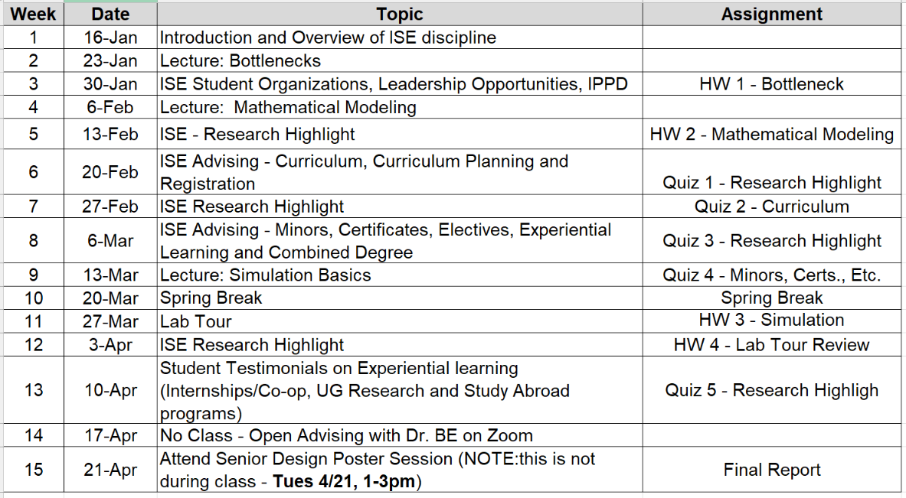

Important Dates:
The final paper will be based on a senior design project. You must attend the ISE senior design poster session to find a project to report on. The poster session will be on TUESDAY 4/21.

Attendance Policy, Class Expectations and Make-Up Policy
Attendance is required and will be collected via iClicker in class. You may have one unexcused absence without penalty. Requirements for class attendance and make-up exams, assignments, and other work in this course are consistent with university policies that can be found at: https://catalog.ufl.edu/ugrad/current/regulations/info/attendance.aspx

Evaluation of Grades
Your grade will be based on attendance, quizzes, homeworks, and a final assignment.

Assignment | Percentage
iClicker | 15%
Quizzes | 25%
Homeworks | 40%
Final Assignment | 20%

Throughout the semester, you will be given 5 quizzes, the lowest of which will be dropped automatically. In each quiz, you will be asked questions from topics discussed in the previous class meeting(s). The quizzes will be short in duration (~5 min), taking up only a small part of the class period. In addition, you will be given 4 homework assignments to be turned in via E-learning, the lowest of which will be dropped automatically.
For your final assignment, you are required to go to the senior design poster session at the end of the semester and write a paper about one project that you liked. The paper will include the following sections:
- Abstract,
- Background and Motivation for the project,
- Project Description including methodology, data collection, implementation and challenges,
- Analysis of results and outcomes,
- Reflection (what interested you about the project).
You may have one unexcused absence without penalty. Each additional unexcused absence count against your iClicker grade.
Also, keep in mind that this is a required course for ISE students. This means that you must earn, at a minimum, a C (73) in order to satisfy the requirement.

Grading Policy
Percent | Grade
93 - 100 | A
90 – 92.9 | A-
87 – 89.9 | B+
83 – 86.9 | B
80 – 82.9 | B-
77 – 79.9 | C+
73 – 76.9 | C
70 – 72.9 | C-
67 – 69.9 | D+
63 – 66.9 | D
60 – 62.9 | D-
0 – 59.9 | E
More information on UF grading policy may be found at: https://catalog.ufl.edu/ugrad/current/regulations/info/grades.aspx

More information on UF grading policy may be found at: https://go.ufl.edu/syllabuspolicies

Classroom Expectations
All students are expected to maintain a professional attitude during lectures, exercises, discussions, and exams. This includes treating everyone with respect, listening actively, and responding using professional and courteous language. Everyone is welcome in this classroom, and all questions are valued. Every student deserves the opportunity to learn in a safe, inclusive, and professional environment.

For more resources, please see https://syllabus.ufl.edu/syllabus-policy/uf-syllabus-policy-links/
(Ex: DRC students, academic resources, University Honesty Policy, etc)

